TWO BIT HALF SUBTRACTOR

EXP.NO: 22

AIM:

To design and implement the two bit half subtractor
using Logisim simulator.

PROCEDURE:

1) Pick and place the necessary gates.

2) Insert 2
inputs into the canvas.

3) Connect
the inputs to the OR gate, AND gate and NOT gate.

4) Insert
2 outputs into the canvas.

5)
Make the connections using the
connecting wires.

6) Verify the truth table.

TRUTH TABLE:

Diff=A'B+AB'

Borrow = A'B

OUTPUT

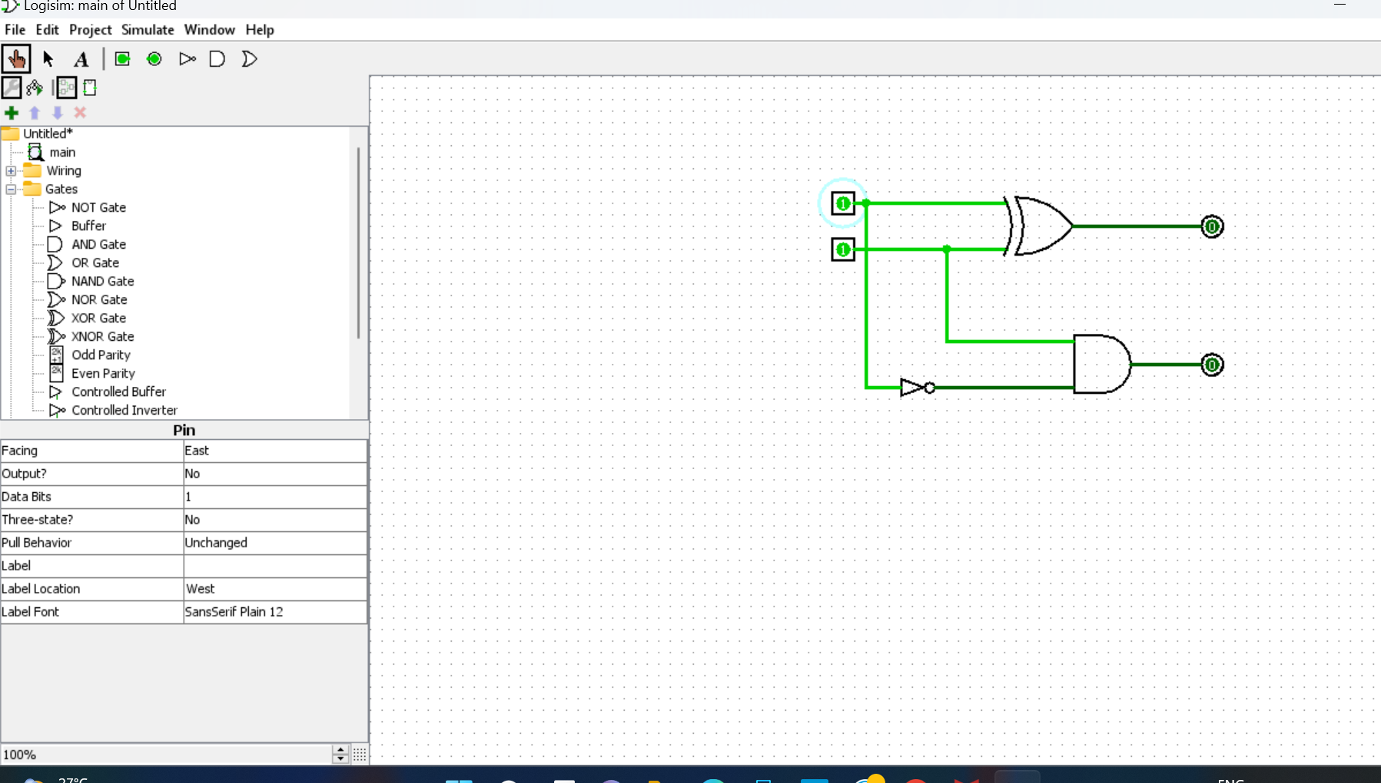

RESULT: Thus 2-bit half subtractor has been
designed and implemented successfully using logisim simulator.

